# CS 305 Module Two Coding Assignment Template – Armon Wilson

## Instructions

Replace the bracketed text with the relevant information in your own words. If you choose to include images or supporting materials, make certain to insert them in all the relevant locations in the document.

## Run Dependency Check

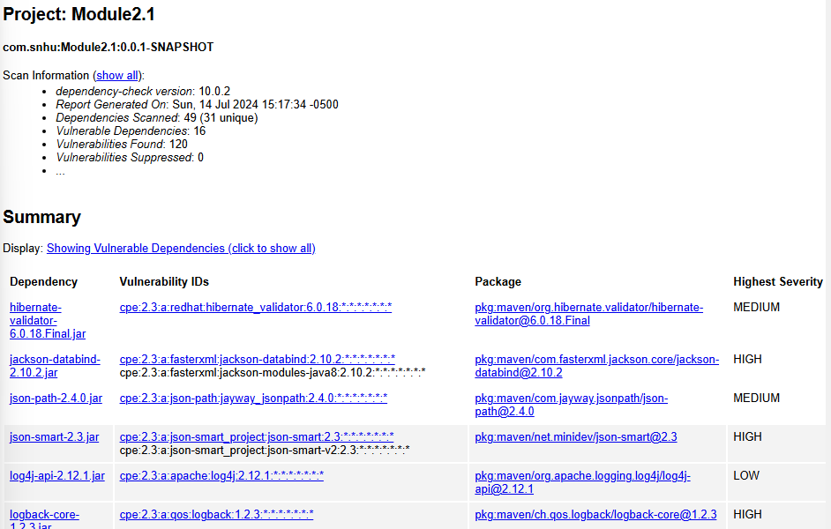

## Document Results

Please refer included excel spreadsheet, “Dependency Check & Analysis”, “Results” tab.

## Analyze Results

Please refer included excel spreadsheet, “Dependency Check & Analysis”, “Analysis” tab